Loading X Files And Messing
With the Camera

In this chapter we will talk about loading X files, for more information on X files refer to chapter 1 and 2. We will also talk about moving the camera.

 Code to load X Files
 Rendering the Sample Application
 Messing around with the camera
 Final Thoughts

6
D
I
R
E
T
3
D
I
M
M
E
D
I
A
T
E

M
O
D
E
Code to load X files
Microsoft created a set of functions that allows us to load X files in Direct3D Immediate Mode, since theses functions were created, it is pretty easy to load an X file in a Direct3D Immediate Mode application. I won’t bother to show you the code that Microsoft created that allows us to load X files, all you need to know is that it can be done and Microsoft has already done it for us. (If you are interested in looking at the code that allows us to load X files in Direct3D Immediate Mode, then you can find it in the DirectX SDK directory or on the CD that supplied you with this Direct3D information). The following is the code for the sample application that loads an X file; the code that does the X file stuff is in bold:

#define STRICT
#define D3D_OVERLOADS
#include <windows.h>
#include <commdlg.h>
#include <math.h>
#include <stdio.h>
#include "D3DTextr.h"
#include "D3DUtil.h"
#include "D3DMath.h"
#include "resource.h"
#include "XFileLoader.h"

//-----------------------------------------------------------------------------
// Declare the application globals for use in WinMain.cpp
//-----------------------------------------------------------------------------
TCHAR* g_strAppTitle = TEXT( "Loading .X files in D3DIM" );
BOOL g_bAppUseZBuffer = TRUE;
BOOL g_bAppUseBackBuffer = TRUE;

//-----------------------------------------------------------------------------
// Defines, constants, and global variables
//-----------------------------------------------------------------------------
LPDIRECT3DMATERIAL3 g_pmtrlObjectMtrl = NULL;
LPDIRECT3DLIGHT g_pLight = NULL;
CD3DFileObject* g_pFileObject = NULL;
BOOL g_bNewFileObject = FALSE;

//-----------------------------------------------------------------------------
// Function prototypes and global (or static) variables
//-----------------------------------------------------------------------------
VOID AppPause( BOOL );
HRESULT App_InitDeviceObjects( LPDIRECT3DDEVICE3, LPDIRECT3DVIEWPORT3 );
VOID App_DeleteDeviceObjects( LPDIRECT3DDEVICE3, LPDIRECT3DVIEWPORT3 );
CHAR* PromptUserForFileToLoad( HWND );
LRESULT CALLBACK WndProc( HWND, UINT, WPARAM, LPARAM );

//-----------------------------------------------------------------------------
// Name: App_OneTimeSceneInit()
// Desc: Called during initial app startup, this function performs all the
// permanent initialization.
//-----------------------------------------------------------------------------
HRESULT App_OneTimeSceneInit( HWND hWnd )
{
// Create a container for the object to hold the xfile data
g_pFileObject = new CD3DFileObject();

g_pFileObject->Load( "car.x" );

// If the file was loaded, exit the loop. Else, display an error.
if( g_pFileObject )
g_bNewFileObject = TRUE;
else
MessageBox( NULL, TEXT("Error loading specified X file"),
TEXT("XFile"), MB_OK|MB_ICONERROR );

return S_OK;
}

//-----------------------------------------------------------------------------
// Name: App_FrameMove()
// Desc: Called once per frame, the call is the entry point for animating
// the scene.
//-----------------------------------------------------------------------------
HRESULT App_FrameMove( LPDIRECT3DDEVICE3 pd3dDevice, FLOAT fTimeKey )
{
// Setup the world spin matrix
D3DMATRIX matRotateY;
D3DUtil_SetRotateYMatrix( matRotateY, fTimeKey/2 );
pd3dDevice->SetTransform( D3DTRANSFORMSTATE_WORLD, &matRotateY );

return S_OK;
}

//-----------------------------------------------------------------------------
// Name: App_Render()
// Desc: Called once per frame, the call is the entry point for 3d
// rendering. This function sets up render states, clears the
// viewport, and renders the scene.
//-----------------------------------------------------------------------------
HRESULT App_Render( LPDIRECT3DDEVICE3 pd3dDevice,
LPDIRECT3DVIEWPORT3 pvViewport, D3DRECT* prcViewRect )
{
//Clear the viewport
pvViewport->Clear2( 1UL, prcViewRect, D3DCLEAR_TARGET|D3DCLEAR_ZBUFFER,
0x000000ff, 1.0f, 0L );

// Begin the scene
if( SUCCEEDED( pd3dDevice->BeginScene() ) )
{
if( g_pFileObject )
g_pFileObject->Render( pd3dDevice, g_pmtrlObjectMtrl );

// End the scene.
pd3dDevice->EndScene();
}

return S_OK;
}

//-----------------------------------------------------------------------------
// Name: App_InitDeviceObjects()
// Desc: Initialize scene objects.
//-----------------------------------------------------------------------------
HRESULT App_InitDeviceObjects( LPDIRECT3DDEVICE3 pd3dDevice,
LPDIRECT3DVIEWPORT3 pvViewport )
{
// Check parameters
if( NULL==pd3dDevice || NULL==pvViewport )
return E_INVALIDARG;

// Get a ptr to the ID3D object to create materials and/or lights. Note:
// the Release() call just serves to decrease the ref count.
LPDIRECT3D3 pD3D;
if( FAILED( pd3dDevice->GetDirect3D( &pD3D ) ) )
return E_FAIL;
pD3D->Release();

HRESULT hr;
D3DMATERIAL mtrl;
D3DMATERIALHANDLE hmtrl;

// Create and set up the object material
if( FAILED( hr = pD3D->CreateMaterial( &g_pmtrlObjectMtrl, NULL ) ) )
return E_FAIL;

D3DUtil_InitMaterial( mtrl, 1.0f, 1.0f, 1.0f );
g_pmtrlObjectMtrl->SetMaterial( &mtrl );
g_pmtrlObjectMtrl->GetHandle( pd3dDevice, &hmtrl );
pd3dDevice->SetLightState( D3DLIGHTSTATE_MATERIAL, hmtrl );
pd3dDevice->SetLightState( D3DLIGHTSTATE_AMBIENT, 0x0 );

D3DTextr_RestoreAllTextures( pd3dDevice );
pd3dDevice->SetTextureStageState( 0, D3DTSS_COLORARG1, D3DTA_TEXTURE );
pd3dDevice->SetTextureStageState( 0, D3DTSS_COLOROP, D3DTOP_SELECTARG1 );
pd3dDevice->SetTextureStageState( 0, D3DTSS_MINFILTER, D3DTFN_LINEAR );
pd3dDevice->SetTextureStageState( 0, D3DTSS_MAGFILTER, D3DTFG_LINEAR );
pd3dDevice->SetRenderState( D3DRENDERSTATE_DITHERENABLE, TRUE );
pd3dDevice->SetRenderState( D3DRENDERSTATE_SPECULARENABLE, FALSE );
pd3dDevice->SetRenderState( D3DRENDERSTATE_ZENABLE, TRUE );

// Set the transform matrices
D3DVECTOR vEyePt = D3DVECTOR( 0.0f, 0.0f, -8.5f );
D3DVECTOR vLookatPt = D3DVECTOR( 0.0f, 0.0f, 0.0f );
D3DVECTOR vUpVec = D3DVECTOR( 0.0f, 1.0f, 0.0f );
D3DMATRIX matWorld, matView, matProj;

// If we have an object loaded, position the view accordingly
if( g_pFileObject )
{
FLOAT fRadius;
g_pFileObject->GetBoundingSphere( &vLookatPt, &fRadius );
vEyePt = D3DVECTOR( 0.0f, 0.0f, fRadius*3.0f ) + vLookatPt;

g_bNewFileObject = FALSE;
}

D3DUtil_SetIdentityMatrix( matWorld );
D3DUtil_SetViewMatrix( matView, vEyePt, vLookatPt, vUpVec );
D3DUtil_SetProjectionMatrix( matProj, g_PI/4, 1.0f, 1.0f, 1000.0f );

pd3dDevice->SetTransform( D3DTRANSFORMSTATE_WORLD, &matWorld );
pd3dDevice->SetTransform( D3DTRANSFORMSTATE_VIEW, &matView );
pd3dDevice->SetTransform( D3DTRANSFORMSTATE_PROJECTION, &matProj );

// Set up the light
if( FAILED( hr = pD3D->CreateLight( &g_pLight, NULL ) ) )
return E_FAIL;

D3DLIGHT light;
D3DUtil_InitLight( light, D3DLIGHT_DIRECTIONAL, 0.0f, -1.0f, -1.0f );
light.dvAttenuation0 = 1.0f;
g_pLight->SetLight( &light );
pvViewport->AddLight( g_pLight );

return S_OK;
}

//-----------------------------------------------------------------------------
// Name: App_FinalCleanup()
// Desc: Called before the app exits, this function gives the app the chance
// to cleanup after itself.
//-----------------------------------------------------------------------------
HRESULT App_FinalCleanup( LPDIRECT3DDEVICE3 pd3dDevice,
LPDIRECT3DVIEWPORT3 pvViewport )
{
App_DeleteDeviceObjects( pd3dDevice, pvViewport );

SAFE_DELETE( g_pFileObject );

return S_OK;
}

//-----------------------------------------------------------------------------
// Name: App_DeleteDeviceObjects()
// Desc: Called when the app is exitting, or the device is being changed,
// this function deletes any device dependant objects.
//-----------------------------------------------------------------------------
VOID App_DeleteDeviceObjects( LPDIRECT3DDEVICE3 pd3dDevice,
LPDIRECT3DVIEWPORT3 pvViewport )
{
D3DTextr_InvalidateAllTextures();

SAFE_RELEASE( g_pLight );
SAFE_RELEASE( g_pmtrlObjectMtrl );
}

//----------------------------------------------------------------------------
// Name: App_RestoreSurfaces
// Desc: Restores any previously lost surfaces. Must do this for all surfaces
// (including textures) that the app created.
//----------------------------------------------------------------------------
HRESULT App_RestoreSurfaces()
{
return S_OK;
}

//-----------------------------------------------------------------------------
// Name: App_ConfirmDevice()
// Desc: Called during device intialization, this code checks the device
// for some minimum set of capabilities
//-----------------------------------------------------------------------------
HRESULT App_ConfirmDevice( DDCAPS* pddDriverCaps,
D3DDEVICEDESC* pd3dDeviceDesc )
{
return S_OK;
}

Section 1
The only thing we do in this section takes place in the variables section of the code. All we are doing is setting up a variable that will hold the information for the X file.

Section 2
In this section, we first create a container for the object to hold the X file (we defined the object in section 1). Next, we load the X file and then we check to see if the file loaded ok.

Section 3
In this section all we do is render the X file.

Section 4
In this section we delete the object. We do this because we are shutting down the application.

Rendering the Sample Application

Step 1
Create a new Win32 Application:

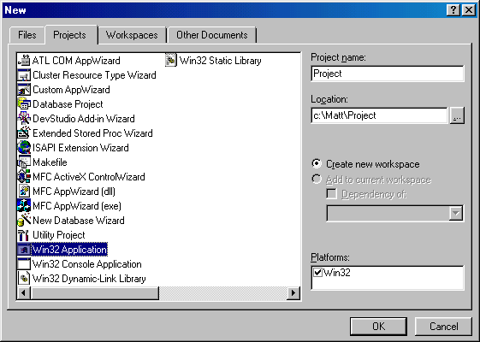
Figure 4.2 – New Win32 Project

Step 2
In this step I want to make sure you have your compiler setup properly, you should make sure the library path and the include path looks like (you can get to these settings by click: Tools->Options->Directories):

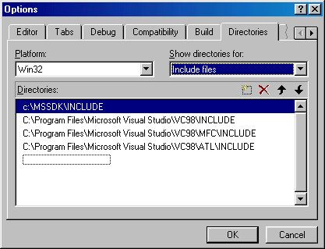
Figure 4.3 – Include Directories

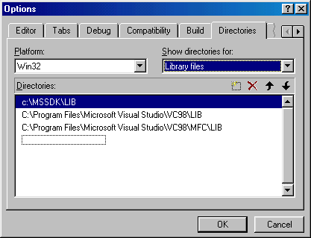
Figure 4.4 – Library Directories

Step 3
The next thing we need to do is add all the files to our project; all you have to do is drag all the files from the source directory to your project. The following is a list of the files you need to add to your project:

xfile.cpp – This file can be found in the source directory on the CD.
xfileloader.cpp – This file can be found in the source directory on the CD.
xfileloader.h – This file can be found in the source directory on the CD.
winmain.cpp – This file can be found in the source directory on the CD.
winmain.rc – This file can be found in the source directory on the CD.
d3dframe.h – This file can be found in the source directory on the CD.
d3dtextr.h – This file can be found in the source directory on the CD.
d3dutil.h – This file can be found in the source directory on the CD.
resource.h – This file can be found in the source directory on the CD.
d3dframe.lib – This file can be found in the source directory on the CD.
dxguid.lib – This file can be found in the DirectX SDK directory. Usually: C:\mssdk\lib
ddraw.lib – This file can be found in the DirectX SDK directory. Usually: C:\mssdk\lib
d3dxof.lib – This file can be found in the DirectX SDK directory. Usually: C:\mssdk\lib
Winmm.lib – This file can be found in the directory for the compiler.

Step 4
Compile the project.

Messing around with the camera
In this section we will talk about creating the view matrix; the view matrix is the camera. There are many ways you can create the view matrix, but the approach we are using is pretty easy, because we can use a function that is part of the D3D framework. The approach we are using creates the composite view matrix directly. This approach uses the camera's world space position and a "look-at point" within the scene to derive vectors that describe the orientation of the camera space coordinate axes. The camera position is subtracted from the look-at point to produce a vector for the camera's direction vector (vector n). Then the cross product of the vector n and the y-axis of world space is taken and normalized to produce a "right" vector (vector u). Next, the cross product of the vectors u and n is taken to determine an "up" vector (vector v). The right (u), up (v), and view-direction (n) vectors describe the orientation of the coordinate axes for camera space in terms of world space.

To setup a view matrix we first need to setup three vectors – position vector, look at point vector, and the up vector. This is done using code that looks like the following:

// Set the transform matrices
D3DMATRIX matView;
D3DVECTOR vEyePt = D3DVECTOR( 0, 0, -2.5 );
D3DVECTOR vLookatPt = D3DVECTOR( 0, 0, 0 );
D3DVECTOR vUpVec = D3DVECTOR( 0, 1, 0 );

D3DUtil_SetViewMatrix( matView, vEyePt, vLookatPt, vUpVec );

pd3dDevice->SetTransform( D3DTRANSFORMSTATE_VIEW, &matView );

The only thing we are doing in the above code fragment is creating a variable to hold the view matrix, and then we setup the three vectors. All we do when we setup the three vectors is move the camera back on the z-axis. This allows us to get a bigger object in front of the camera without cutting any of the object off.

Next, we call the helper function to create the view matrix and finally we register the view matrix with Direct3D.

Final Thoughts
I hope you have enjoyed reading this mini Direct3D book, with all the information you should have picked up from this book you should be able to build a decent Direct3D application from scratch. You should be able to render your scenes using a 3D accelerator, or software if no 3D card is present. You should also be able to do cool special effects using single pass multi texturing; just remember that the video card your application is running on should have support for single pass multi texturing. I hope this book has helped you in your journey through Direct3D Immediate Mode and Retained Mode. If you would like to contact me you can email me: matt@magmagames.com

